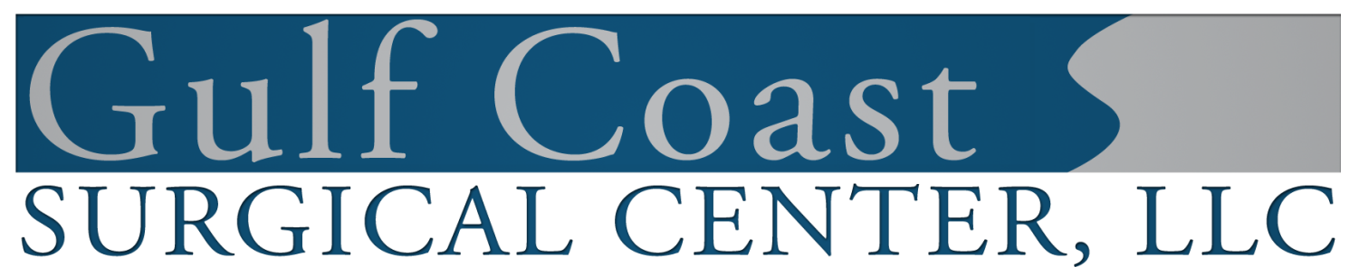
402 Dunn Street ● Houma, LA 70360 ● (985) 872-1661● Fax (985) 868-6938

To our patients:

For your convenience, you are being referred to Gulf Coast Surgical Center for your surgery. The Center is a state licensed Ambulatory Surgery Center which is partially owned by: Dr. Lawrence Haydel, Dr. Brett Casey, Dr. Christopher Cenac, Jr., Dr. Matthew Beyer, Dr. David Hagen, Dr. Chad Simon, Dr. Michael Haydel, Dr. Guy Zeringue, III, Dr. J. Vance Broussard, Dr. Justin Tenney, Dr. Jacques Gaudet, Dr. Patrick Hagen, Dr. Haden Lafaye, Dr. Stephen Charbonnet, Dr. Geoffrey Stone, and Dr. Sina Pourtaheri.
Your comments and thoughts on the services rendered to you by the doctors and staff of Gulf Coast Surgical Center are appreciated.

Sincerely,

Allison Porretto, RN, BSN, CNOR, CASC
Director of Nursing

